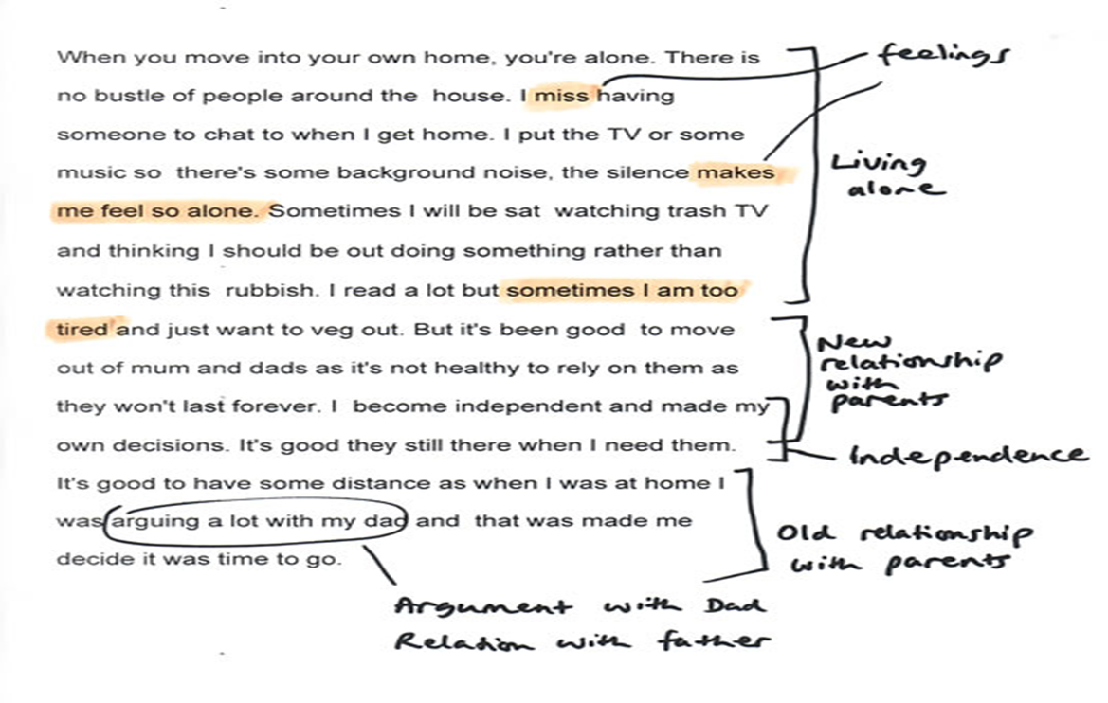

2. Watch the video given by the link on Types of Data ( 6 mins)

<https://youtu.be/hZxnzfnt5v8>